Eyedrivomatic Components List

For one complete Eyedrivomatic System (one brain box, electronic hand, and adjustable locator)

1 x 3d printed parts for brain box (base plate, lid, and two cable retaining pieces) £variable
1 x 3d printed parts for Electronic hand (base piece, X servo carrier, lower ring, Y servo carrier,
upper ring, transmission arm. £variable
1 x 3d printed joystick sleeve (internal diameter to snugly fit your joystick shaft) £variable
1 x 3d printed parts for adjustable locator plate (lower ring, upper ring, retaining ring) £variable
1 x Arduino Uno R3. £6 - £16
2 x Turnigy 380Max Micro servo (or similar high torque micro servo) £15 each
1 x Powerbee Executive solar phone charger (optional. Possible to use the wheelchair battery) £19
2 x metal 25t servo arms (the design calls for a specific model, see illustration) £1.20
1 x relay shield (the design calls for a specific model. Please see illustration below) £7
1 x servo/sensor shield (the design calls for a specific model. Please see illustration below) £5
1 x USB A to USB B cable (length required depends on where your brain box will be located) £1.50
1 x USB A to DC plug (the particular type of DC plug isn't important, as it will be removed) £1.50
2 x servo extension cables, male to female (again length required depends on location) £2
20 x No6 Pan head, Pozi self tapping screws 13mm £1
10 x No6 Pan head, Pozi self tapping screws 16mm £1
10 x M3 bolt, countersunk, pozi £1
10 x M3 nyloc nut £1
10 x M3 flat washers £1.50
1 x self adhesive hook and loop tape. 20mm wide. 60cm of hook and the same of loop £2.70
1 x Super Glue £2
1 x double sided foam tape (5 or 10mm wide, or cut down from a wider roll) £2.50
Total Cost (excluding 3d printing) £70 - £99

Prices are based on ebay UK prices, for UK stock, available for immediate delivery. Correct at time of writing (20 Oct 2015)

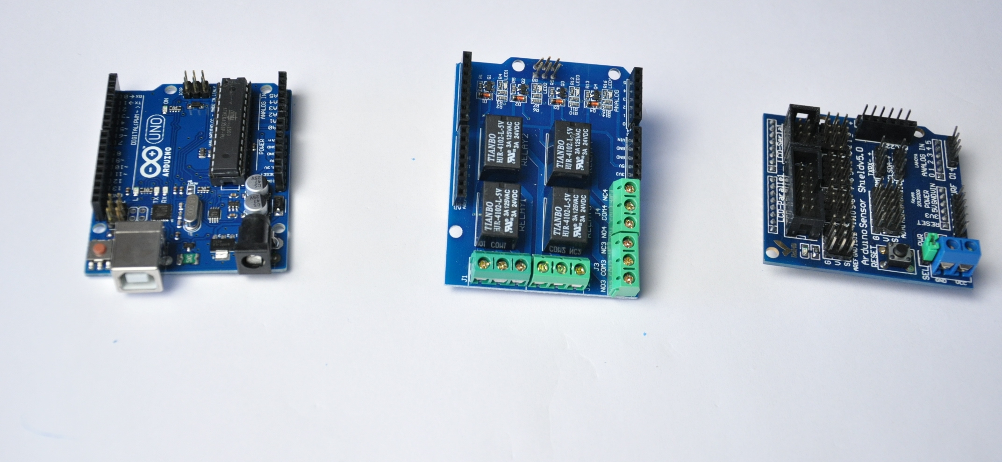
left to right; Arduino uno r3, 4 channel relay shield, servo/sensor shield

